Dragon King Star Beam Light
Instructions for use
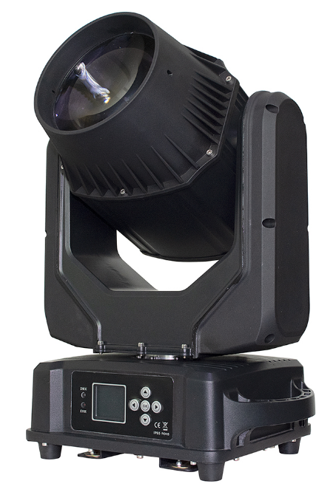
Please read the instructions carefully before use

Table of contents
Chapter 1. Notes and Installation 1
1. Maintenance 1
2. statement 1
3. Product precautions 1
4. Installation of lamps and lanterns 1
Chapter 2. Panel Operation 3
1. Lamp panel 3
2. Menu header interface 3
2.1., The system setup 4
2.2., System for calibration 6
2.3., The system is reset 7
2.4., System information 7
Chapter 3: Channel description and technical parameters 9
1. Channel table 9
2.Technicalparameters:.......................................................................... ...............11
Chapter 4 Common faults and use attention.................................................... ..12
1. Common fault handling 12
2. Notes for use 13
3. Notes for the use of RDM 13

Notes and installation

tending
- This lamp shall be kept dry to avoid working in a wet environment.
- Intermittent use will effectively prolong the life of this lamp.
- In order to achieve good ventilation and lighting effects, pay attention to regularly clean the fans and fan nets and lenses.
- Do not wipe the lamp shell with organic solvents such as alcohol to avoid damage.

statement
This product in the factory, the performance is intact, complete packaging. All users shall strictly comply with the warnings and operating instructions stated above, any damage caused by misuse is not covered by the Company's warranty and the faults and problems caused by the neglect of the operating manual.
This manual is subject to technical changes without prior notice.

Precautions for products
- In order to ensure the service life of the product, the product should not be placed in a wet or leaky place, nor to work in the temperature above 60 degrees
- Do not place the product in a place that is easy to loosen or vibrate.
- In order to avoid the danger of electric shock, this product.
- When the bulb is used, the voltage change of the power supply should not exceed ± 10%. If the voltage is too high, it will shorten the life of the bulb. If the voltage is too low, it will affect the light color of the bulb.
- After power failure, the lamp again needs 20 minutes of full cooling before it can be energized again.
- To ensure the normal use of this product, please read the instructions carefully.
- Signal line connection (DMX)
Use specification compliant RS-485 cable: with shielding, 120 ohm characteristic impedance, 22-24 AWG, low tolerance. Do not use microphone cables or cables with different specified characteristics. The als must be connected with a 3 or 5-pin XLR male / female connector (minimum 1 / 4 W). Figure 1 shows the schematic diagram of the signal line connection (the lamp in the figure is an example picture and does not represent the true appearance of the product).
Important: The ines shall not contact each other or with the metal shell.
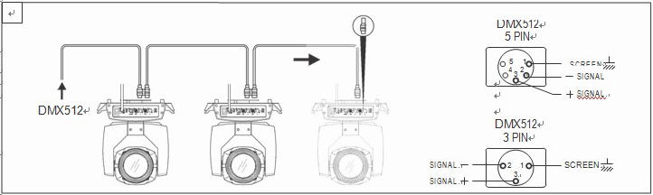
Figure 1 Schematic diagram of the DMX signal line connection

4. Lighting installation
Lamps can be placed horizontally, oblique and upside down. We must pay attention to the installation method when hanging in oblique and inverted hanging.
As shown in figure 2, (the lamps and lanterns for the example picture, does not represent the real appearance of the product) before the positioning of lamps and lanterns, to ensure the stability of the installation site, in the reverse hanging installation, must ensure that the lamps and lanterns do not fall down on the support frame, need to use safety rope through the support frame and lamps handle for auxiliary hanging, to ensure safety, prevent lamps and lanterns from falling and sliding.
When the lamps are installed and tested, pedestrians are not allowed to pass below. Regularly check whether the safety rope is worn and whether the hook screws are loose.
Our company shall not bear any responsibility for all the consequences caused by the unstable installation of the hanging and the lamp falling.
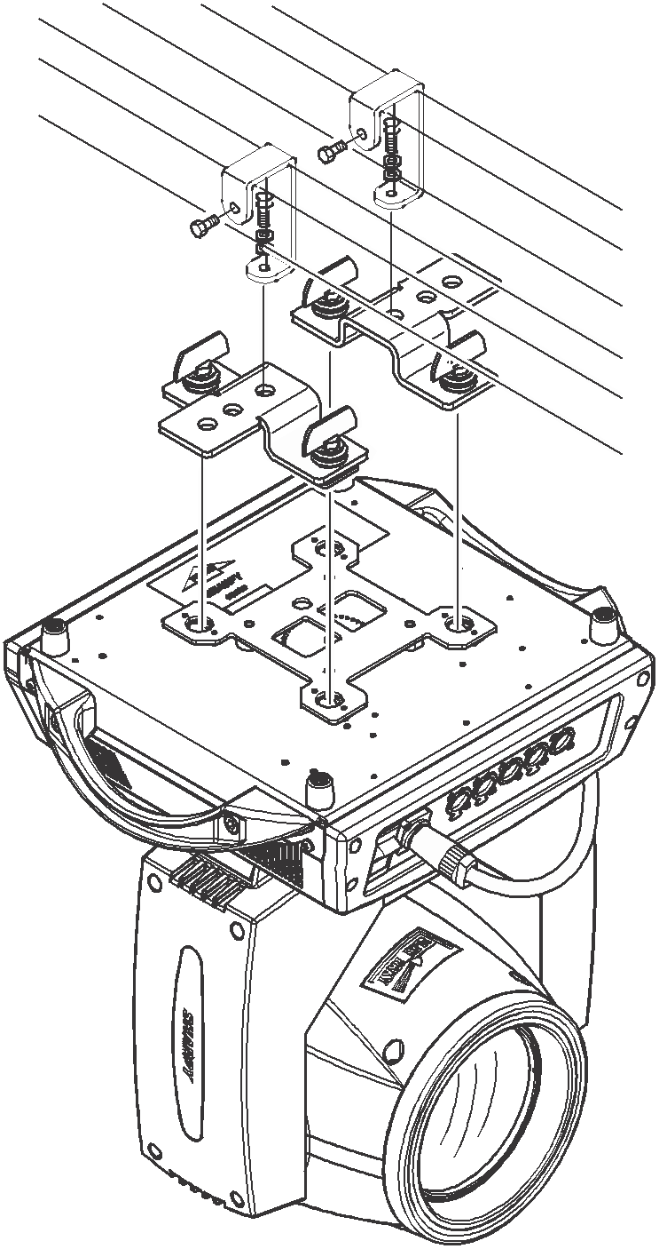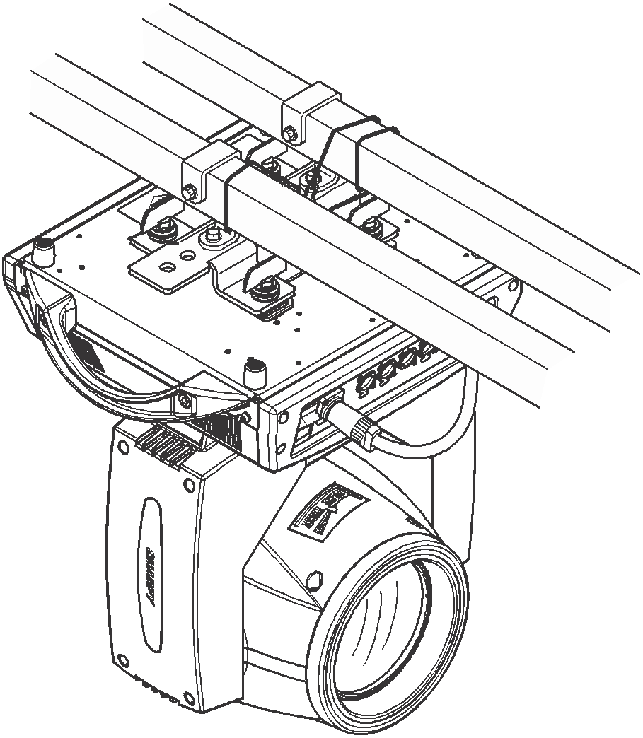
Figure 2 Schematic diagram of the inverted lamp

Panel operation

Lamp panel
The schematic diagram of the lamp panel is shown in Figure 3:
1) Signal light: DMX signal light is above and the blue light is connected with the console. No light is in normal condition. When the lamp is wrong, red light is in normal condition.
2) Temperature: as shown in the picture, the temperature of the lamp board is 30 degrees Celsius; if the temperature shows * * ℃, the temperature of the lamp is abnormal. It may break the temperature control connection line. If the temperature shows 99℃, and the difference from the ambient temperature is too large, it may be a temperature control cable short circuit. Need professionals to repair and troubleshoot, before normal use.
Temperature and power: When the temperature reaches 75 degrees, the power drops to 80 degrees, directly turn the light off. After the drop power, the temperature is below 75 degrees (excluding 75 degrees).
Temperature and fan: When the fan starts on for 15 seconds, the air will be detected all the time; when the temperature reaches 46 degrees and stops below 43 degrees.
3) Address code: display range 001-512, the address code is 001.
4) DMX mode: 512 mode.
5) Press the button: UP: press up
MENU: Return to the previous level menu
ENTER: as determined
DOWN: down
Note: Never use sharp or sharp objects to click on the display to prevent damage.
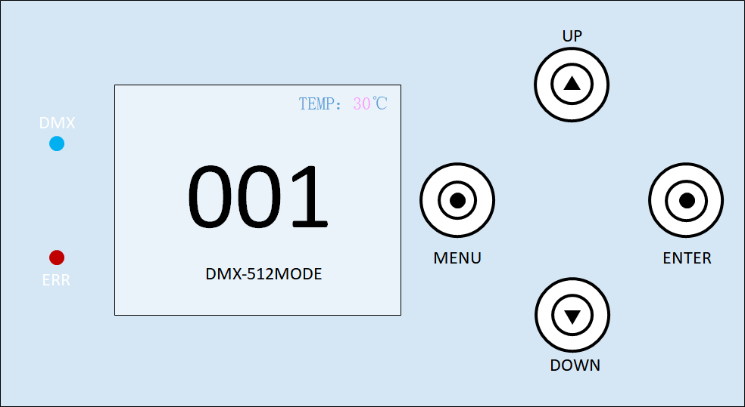

Figure Figure 3 Five keys show a schematic diagram of the panel

Menu first interface
The first interface of the menu contains 6 sub-menus. Select the corresponding sub-menu through the "UP" key and "DOWN" key, and click the "ENTER" key to enter the corresponding sub-menu interface. The first interface of the menu is shown in Figure 4:
1) Address: Click to enter the address code setting. the number of address codes can be increased or reduced by the "UP" and "DOWN" keys. At this time, the address code displayed on the lamp panel will be updated synchronously.
2) Settings: Click to enter the system Settings to change the working mode, working parameters and panel display Settings of the lamp.
3) Manual: Click to enter the manual mode to control the function of the lamp. For the specific content, see the channel table.
4) Calibration: Click the input password to enter the calibration interface, and you can adjust the lamp power, motor stroke, sound control sensitivity and other parameters.

5) Reset: click to enter the system reset mode.

- Information: Click to enter the system error correction, hardware and software version and other information.

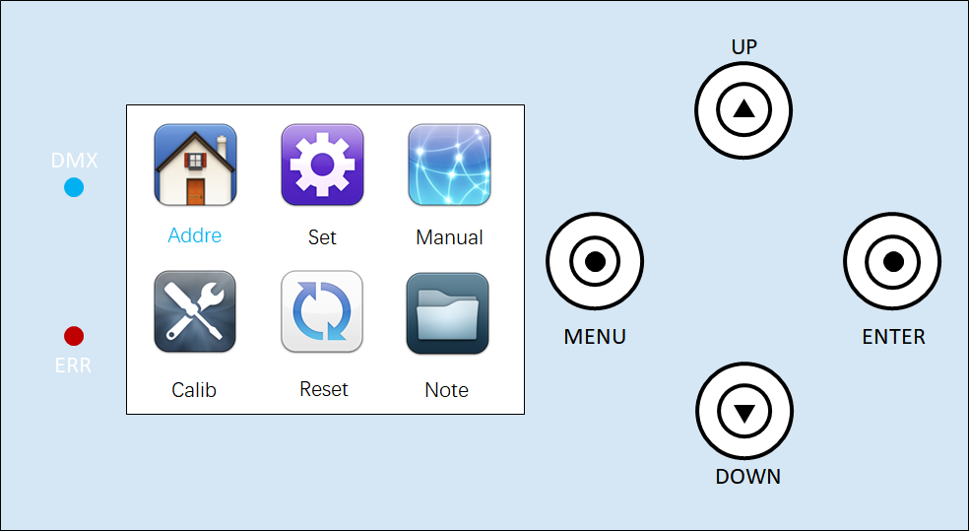

Figure 44 determines the input window

2.1 System Settings
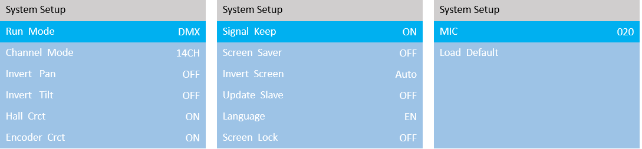

Figure 5. System Settings interface
The system setting interface is shown in Figure 5. Enter the system setting, click "ENTER" to select the settings to be modified, then select the changed content through "UP" and "DOWN", and "ENTER" button to confirm and change the working mode, working parameters and Settings of the panel display. The details are shown in Table 1.
options | illustrate
operating mode | Lamp operating mode: DMX/voice control/self-propelled 1/self-propelled 2/self-propelled 3
operating mode | DMX mode | Console mode, receive DMX signal
operating mode | self-propelled mode 1 | The lamps run automatically according to the built-in self-propelled program 1
operating mode | self-propelled mode 2 | The lamps run automatically according to the built-in self-propelled program 2
operating mode | self-propelled mode 3 | The lamps run automatically according to the built-in self-propelled program 3
operating mode | voice mode | When the lamp detects a strong sound, the lamp automatically runs a scene according to the built-in program, otherwise it keeps the last scene.
channel mode | 14CH
Horizontal inversion | Set the X-axis rotation direction
Horizontal inversion | closure | Not reverse
Horizontal inversion | turn on | reverse
flip vertically | Set the Y-axis rotation direction
flip vertically | closure | Not reverse
flip vertically | turn on | reverse
Hall Error Correction | Detect whether the functions such as gobo wheel and color wheel are out of sync and correct them
Hall Error Correction | closure | No position correction after loss of step
Hall Error Correction | turn on | Automatically correct position after losing step
Optocoupler error correction | Detect whether XY is out of sync and correct it
Optocoupler error correction | closure | Position is not corrected after a misstep
Optocoupler error correction | turn on | Position is automatically corrected after loss of step
signal hold | screen on time
signal hold | closure | Always on
signal hold | turn on | In a static environment, the screen is turned off at regular intervals
screen protector | The screen is bright for a long time
screen protector | closure | Often bright
screen protector | turn on | In a static environment, the screen timing off the screen
screen flip | Set the display direction of the screen
screen flip | closure | No reversal is shown
screen flip | turn on | Reverse display
screen flip | voluntarily | The system can automatically rotate the screen according to the direction of gravity
Synchronization Update | Synchronize the setting parameters or calibration parameters of multiple lamps
Synchronization Update | closure | The synchronous update function is turned off.
Synchronization Update | turn on | After opening, connect multiple lamps with DMX cable, and the information can be updated synchronously in the setting interface and calibration interface.(Note: Remove the DMX signal wire connected to the console)
language | Chinese and English menu switch
language | middle | Chinese
language | EN | English menu
screen lock | After the screen is paused, the screen is locked. For the unlock password, see the unlock interface prompts.
screen lock | closure | Not locked
screen lock | turn on | locking
MIC sensitivity | Adjust the voice control sensitivity, the adjustment range is 0-255, the default value is 20
MIC sensitivity | 0 | The lowest voice control sensitivity
MIC sensitivity | 255 | The highest voice control sensitivity
reset | Lighting parameters are returned to the factory settings
reset | Cancel | keep it as it is
reset | confirm | Restoring the lamps to factory settings
Table 1

2.2 System calibration
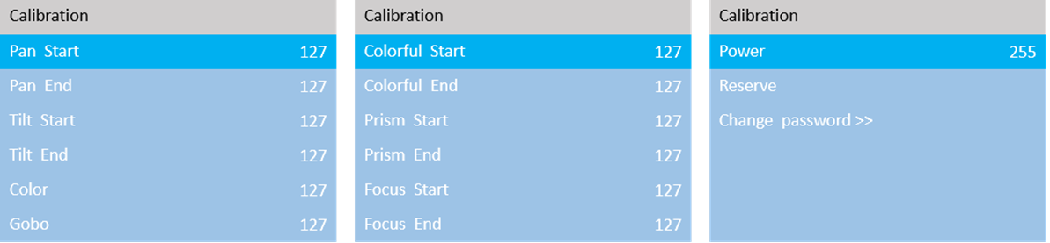
Figure 6. The system calibration interface
Press "6 xxx" to enter the system calibration interface. Modify the value through the "UP" key and "DOWN" key to modify the lamp power, motor stroke, sound control sensitivity and other parameters. The system calibration interface is shown in Figure 6, and the details are shown in Table 2.
options | illustrate
initial position | After entering the sub-interface, you can adjust the initial positions of the X-axis, Y-axis, color plate, map plate, colorful, prism, and focus motor. The adjustment range is 0~255. 127 means no adjustment.
Stroke calibration | After entering the sub-interface, you can adjust the strokes of the X-axis, Y-axis, fog mirror, colorful, prism, and focus motor. The adjustment range is 0~255. 127 means no adjustment.
power | After entering the sub-interface, you can adjust the maximum power of the entire lamp. 255 means the maximum power.
change Password | Set system calibration password
Table 22.3 System reset
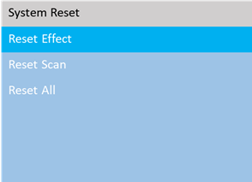
Figure 7. System reset interface

The system reset interface is shown in Figure 7. Press "UP" and "DOWN" keys to switch the reset mode and press "ENTER" to reset directly. See the details in Table 3.

options | illustrate
Effect motor reset | Color wheel, fixation, focus, etc. motor reset
Scan motor reset | Only XY axis reset
All motors reset | Fixture reset
Table 3

2.4 System information
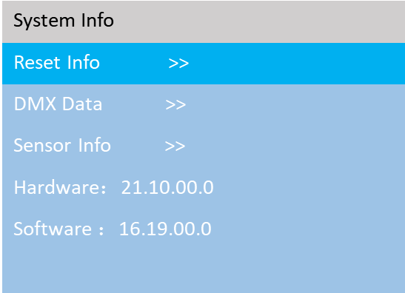
Figure 8. The system information interface
Press the "ENTER" key directly to enter the system information interface, select the "UP" keys and "DOWN", and then click "ENTER" to view the corresponding content. The system calibration interface is shown in Figure 8, and the details are shown in Table 4.

Table 4

Options | Instructions
Reset error message | If the red ERR indicator lights up, the luminaire is operating incorrectly:  1) IC1 communication failure (motor and display board communication failure)  2)X/Y optocoupler error  3)Motor reset failure of color disk, gobo, etc
DMX data monitoring | From this to enter the sub-interface, the channel value is displayed in numerical value for viewing .
Sensor Information | 1) Hall:  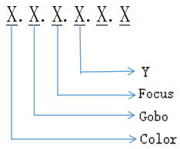  2）Sensor:  X, Y optocoupler: XXXX--XXXX
Hardware version number | Luminaire hardware information  XX . XX . XX  Display board version. Motor board version
Software version number | Lighting software version  XX . XX . XX  Display board version. Motor board version

Channel description and technical parameters

channel table
The detailed data of the channel are shown in Table 5 and can be viewed in the manual interface:
14 channels | Channel function | numeric value | Effect
1 | X-axis | 0-255 | level control
2 | X-axis fine adjustment | 0-255 | Horizontal Control Trim
3 | Y axis | 0-255 | vertical control
4 | Y axis fine adjustment | 0-255 | Vertical control fine-tuning
5 | XY speed | 0-255 | from fast to slow
6 | Dimming | 0-255 | Dimming (from dark to bright)
7 | strobe | 0-3 | invalid
7 | strobe | 4-99 | Synchronous strobe
7 | strobe | 100-149 | pulse strobe
7 | strobe | 150-199 | Strobe
7 | strobe | 200-249 | random strobe
7 | strobe | 250-255 | Consecrate
8 | color wheel | 0-6 | White
8 | color wheel | 7-11 | Color 1:Red
8 | color wheel | 12-16 | Color 2:Green
8 | color wheel | 17-21 | Color 3:Blue
8 | color wheel | 22-26 | Color 4:Yellow
8 | color wheel | 27-31 | Color 5:Rose red
8 | color wheel | 32-36 | Color 6:Yellow green
8 | color wheel | 37-41 | Color 7:Deep blue
8 | color wheel | 42-46 | Color 8:Red purple
8 | color wheel | 47-51 | Color 9:Orange
8 | color wheel | 52-56 | Color 10:Light blue
8 | color wheel | 57-61 | Color 11:Cool color
8 | color wheel | 62-66 | Color 12:Light blue purple
8 | color wheel | 67-71 | Color 13:Brown
8 | color wheel | 72-75 | White light + color 1
8 | color wheel | 76-79 | Color 1+Color 2
8 | color wheel | 80-83 | Color 2 + Color 3
8 | color wheel | 84-87 | Color 3+Color 4
8 | color wheel | 88-91 | Color 4+Color 5
8 | color wheel | 92-95 | Color 5+Color 6
8 | color wheel | 96-99 | Color 6+Color 7
8 | color wheel | 100-103 | Color 7+Color 8
8 | color wheel | 104-107 | Color 8+Color 9
8 | color wheel | 108-111 | Color 9+Color 10
8 | color wheel | 112-115 | Color 10+Color 11
8 | color wheel | 116-119 | Color 11+Color 12
8 | color wheel | 120-123 | Color 12+Color 13
8 | color wheel | 124-127 | Color 13+ white light
8 | color wheel | 128-189 | Water flows counterclockwise from fast to slow
8 | color wheel | 190-193 | Stop flowing water
8 | color wheel | 194-255 | Water flows clockwise from slow to fast
9 | Solid figure | 0-2 | white light hole
9 | Solid figure | 3-6 | Pattern 1
9 | Solid figure | 7-10 | Pattern 2
9 | Solid figure | 11-14 | pattern 3
9 | Solid figure | 15-16 | Pattern 4
9 | Solid figure | 19-22 | Pattern 5
9 | Solid figure | 23-26 | Pattern 6
9 | Solid figure | 27-30 | Pattern 7
9 | Solid figure | 31-34 | Pattern 8
9 | Solid figure | 35-38 | Pattern 9
9 | Solid figure | 39-42 | Pattern 10
9 | Solid figure | 43-46 | Pattern 11
9 | Solid figure | 47-50 | Pattern 12
9 | Solid figure | 51-54 | Pattern 13
9 | Solid figure | 55-58 | Pattern 14
9 | Solid figure | 59-62 | Pattern 15
9 | Solid figure | 63-66 | Pattern 16
9 | Solid figure | 67-70 | Pattern 17
9 | Solid figure | 71-77 | Pattern 1 jitters from slow to fast
9 | Solid figure | 78-84 | Pattern 2 jitters from slow to fast
9 | Solid figure | 85-91 | Pattern 3 jitters from slow to fast
9 | Solid figure | 92-98 | Pattern 4 jitters from slow to fast
9 | Solid figure | 99-105 | Pattern 5 shakes from slow to fast
9 | Solid figure | 106-112 | Pattern 6 shakes from slow to fast
9 | Solid figure | 113-119 | Pattern 7 shakes from slow to fast
9 | Solid figure | 120-126 | Pattern 8 shakes from slow to fast
9 | Solid figure | 127-133 | Pattern 9 shakes from slow to fast
9 | Solid figure | 134-140 | Pattern 10 shakes from slow to fast
9 | Solid figure | 141-147 | Pattern 11 shakes from slow to fast
9 | Solid figure | 148-154 | Pattern 12 shakes from slow to fast
9 | Solid figure | 155-161 | Pattern 13 shakes from slow to fast
9 | Solid figure | 162-168 | Pattern 14 shakes from slow to fast
9 | Solid figure | 169-175 | Pattern 15 shakes from slow to fast
9 | Solid figure | 176-182 | Pattern 16 shakes from slow to fast
9 | Solid figure | 183-189 | Pattern 17 shakes from slow to fast
9 | Solid figure | 190-221 | Flow counterclockwise from fast to slow
9 | Solid figure | 222-223 | Stop flowing water
9 | Solid figure | 224-255 | Clockwise flow from slow to fast
10 | Colorful | 0-127 | Colorful cut out
10 | Colorful | 128-255 | colorful cut
11 | prism | 0-127 | Prism cut out
11 | prism | 128-255 | Prism cut in
12 | prism rotation | 0-127 | 0-400 degrees
12 | prism rotation | 128-190 | Reverse flow from fast to slow
12 | prism rotation | 191-192 | stop
12 | prism rotation | 193-255 | Flowing water from slow to fast
13 | focusing | 0-255 | 0-100% from far to near
14 | reset | 0-199 | invalid
14 | reset | 200-205 | reset all
14 | reset | 206-255 | invalid
Table 5
2. Technical parameters:
Voltage: AC100-240V, 50-60Hz
Rated power: 350W
Light source: brand new 200W white LED module
Pattern: 17 patterns + white light with two-way flow, variable speed jitter effect
Color wheel: 13 colors + white light, two-way variable speed rainbow flow effect
Effect plate: colorful mirror effect
Prism: 8+16 prism can be rotated in two directions with variable speed
XY: magnetic coding precise positioning
Horizontal: 540 degrees + fine adjustment
Vertical: 270 degrees + fine adjustment
Beam Angle: 1.6 degrees
Channel: 14CH
Dimming: 0-100% linear dimming
Strobe: 1-25Hz, random pulse and various strobes
Waterproof grade: IP65
Lifespan: 50,000 hours, low power consumption, energy saving and environmental protection.
Screen: Chinese and English touch screen LCD display showing the current function of the lamp

Common faults and use attention

Common fault handling
Lamps contain microcomputer circuit board, high voltage power supply and other professional components, for your safety and product life, non-professionals do not remove lamps and related accessories without authorization.

Bulb is not light on (except for LED light source)
Possible reasons: The bulb is not fully cooled, or the bulb reaches its life, treated as follows:
- Due to abnormal operation, the bulb is not completely cooled, the light body should be cooled for more than 10 minutes, so that its internal completely restored to the normal state, and then start the power supply again;
- Check whether the light bulb has reached the service life, and replace it with a new light bulb;
- Check whether the bulb and the lamp lighting device circuit leakage, fall off or poor contact;
- Replace the new lamp lighter.

The beam looked dim
Possible reasons: bulb is used long or light path is not clean, as follows:
- Check whether the light bulb has reached the service life, and replace it with a new light bulb;
- Check whether the optical components or bulbs are clean, and whether there is dust accumulation on the bulbs and other optical components, and the bulbs and the components should be cleaned and maintained regularly.

The pattern projection is vague
- Check if the electronic focus channel values are appropriate for the current projection distance.

The light fixtures work intermittently
Possible reasons: The internal line enters the protection state and handles as follows:
- Check whether the fan is running normally or whether it is dirty, causing the temperature inside the lamp to rise;
- Check whether the internal temperature control switch is in a closed state;
- Check the bulb and replace the new bulb.

The control of the console is not accepted after the lamp is normally reset
Possible cause: signal line failure or lamp parameter set abnormal, handled as follows:
- Check the starting address code and the connection of DMX signal line (whether the signal cable is intact and whether the Alcock head connection is loose);
- Add a signal amplifier, add 120 ohm terminal resistance;

The lamps cannot be started
Possible reasons: Poor power line, handled as follows:
- Check whether the insurance on the power input socket is fused and replace the insurance;
- Poor line contact of lamp travel due to vibration in long-distance transportation
- Check the input power supply, computer board and other connecting devices.

Precautions for use
- Check whether the local power supply meets the rated voltage requirements of the product, leakage protector, overcurrent protector and meet the load requirements;
- Do not use damaged power cord with insulation and do not attach power cord to other wires;
- The lamps and lanterns use strong air refrigeration, which is easy to accumulate dust. They must be cleaned once a month, especially the cooling outlet, otherwise it will be blocked due to dust, resulting in poor heat dissipation, so that the lamps appear abnormal.
- When installing the lamps, the fixed screws must be tightened, and equipped with safety cables, and regular inspection;
- In the installation and positioning of the lamp, any point on the surface of the lamp and any burning explosive, keep the minimum distance of 10 meters, the distance from the irradiation is 2.5 meters, please do not install the lamp directly on the surface of combustible material;
- It is recommended that the continuous working time of lamps should not exceed 10 hours, and the interval time of continuous starting lamps should not be less than 10 minutes, otherwise it will not be triggered normally because of the overheating protection of the bulb;
- The closing time of using the on-off valve should not exceed 5 minutes. If the light needs to be closed for a long time, the console (light gun control channel) should be used to turn off the light gun;
- In order to ensure that multiple lamps better comply with the scene effect, the lamps should not always be in the unfinished current scene, that is, start the next scene action, it is best that this state is not more than 3 minutes, to ensure that multiple lamps can run synchronously;
- In the process of use, if the lamps are abnormal, the lamps should be stopped in time to prevent other faults.

RDM use considerations
RDM is an extended version of DMX512-A protocol, which is the remote device management (Remote Device Management) protocol. Traditional DMX512 protocol communication is one-way communication, the protocol is based on RS-485 bus, RS-485 is time-sharing multi-point and semi-duplex protocol, and only one port is allowed for host output at the same time. Therefore, the following points should be noted when using RDM:
- To use a console or host device that supports the RDM protocol host;
- To use the two-way signal amplifier, the traditional one-way signal amplifier is not applicable to the RDM protocol, because the RMD protocol needs feedback data, the use of the one-way amplifier will block the returned data, resulting in the search for lamps;
- All lamps must be set to DMX mode to ensure that there is only one host on the signal line;
- A 120 ohm impedance matching resistance must be inserted between terminals 2 and 3 of the terminal plug. When the signal line is relatively long, the signal reflection, which is conducive to the quality of communication;
- When the lamp is subject to DMX control, but can not RDM search the lamp, first check the signal amplifier, and then check whether the 2 and 3 lines of the signal line have poor contact.

